# **Data Katalyst**

### **Welcome to Data Katalyst**

**Ignite Intelligence. Empower Decisions. Transform Possibilities.**

Data Katalyst is not just a framework—it’s the powerhouse that accelerates your data journey. Built on the strong pillars of **Data Quality**, **Data Governance**, **Data Management**, and **DataOps**, it brings clarity to chaos, turns raw data into reliable insights, and ensures your business decisions are backed by precision and trust.

Whether you're aiming to scale faster, innovate smarter, or govern better—**Data Katalyst is your launchpad to becoming truly data-driven.**

***Data Katalyst: Accelerate Insight. Empower Action.***

## **Pillar 1: Data Quality**

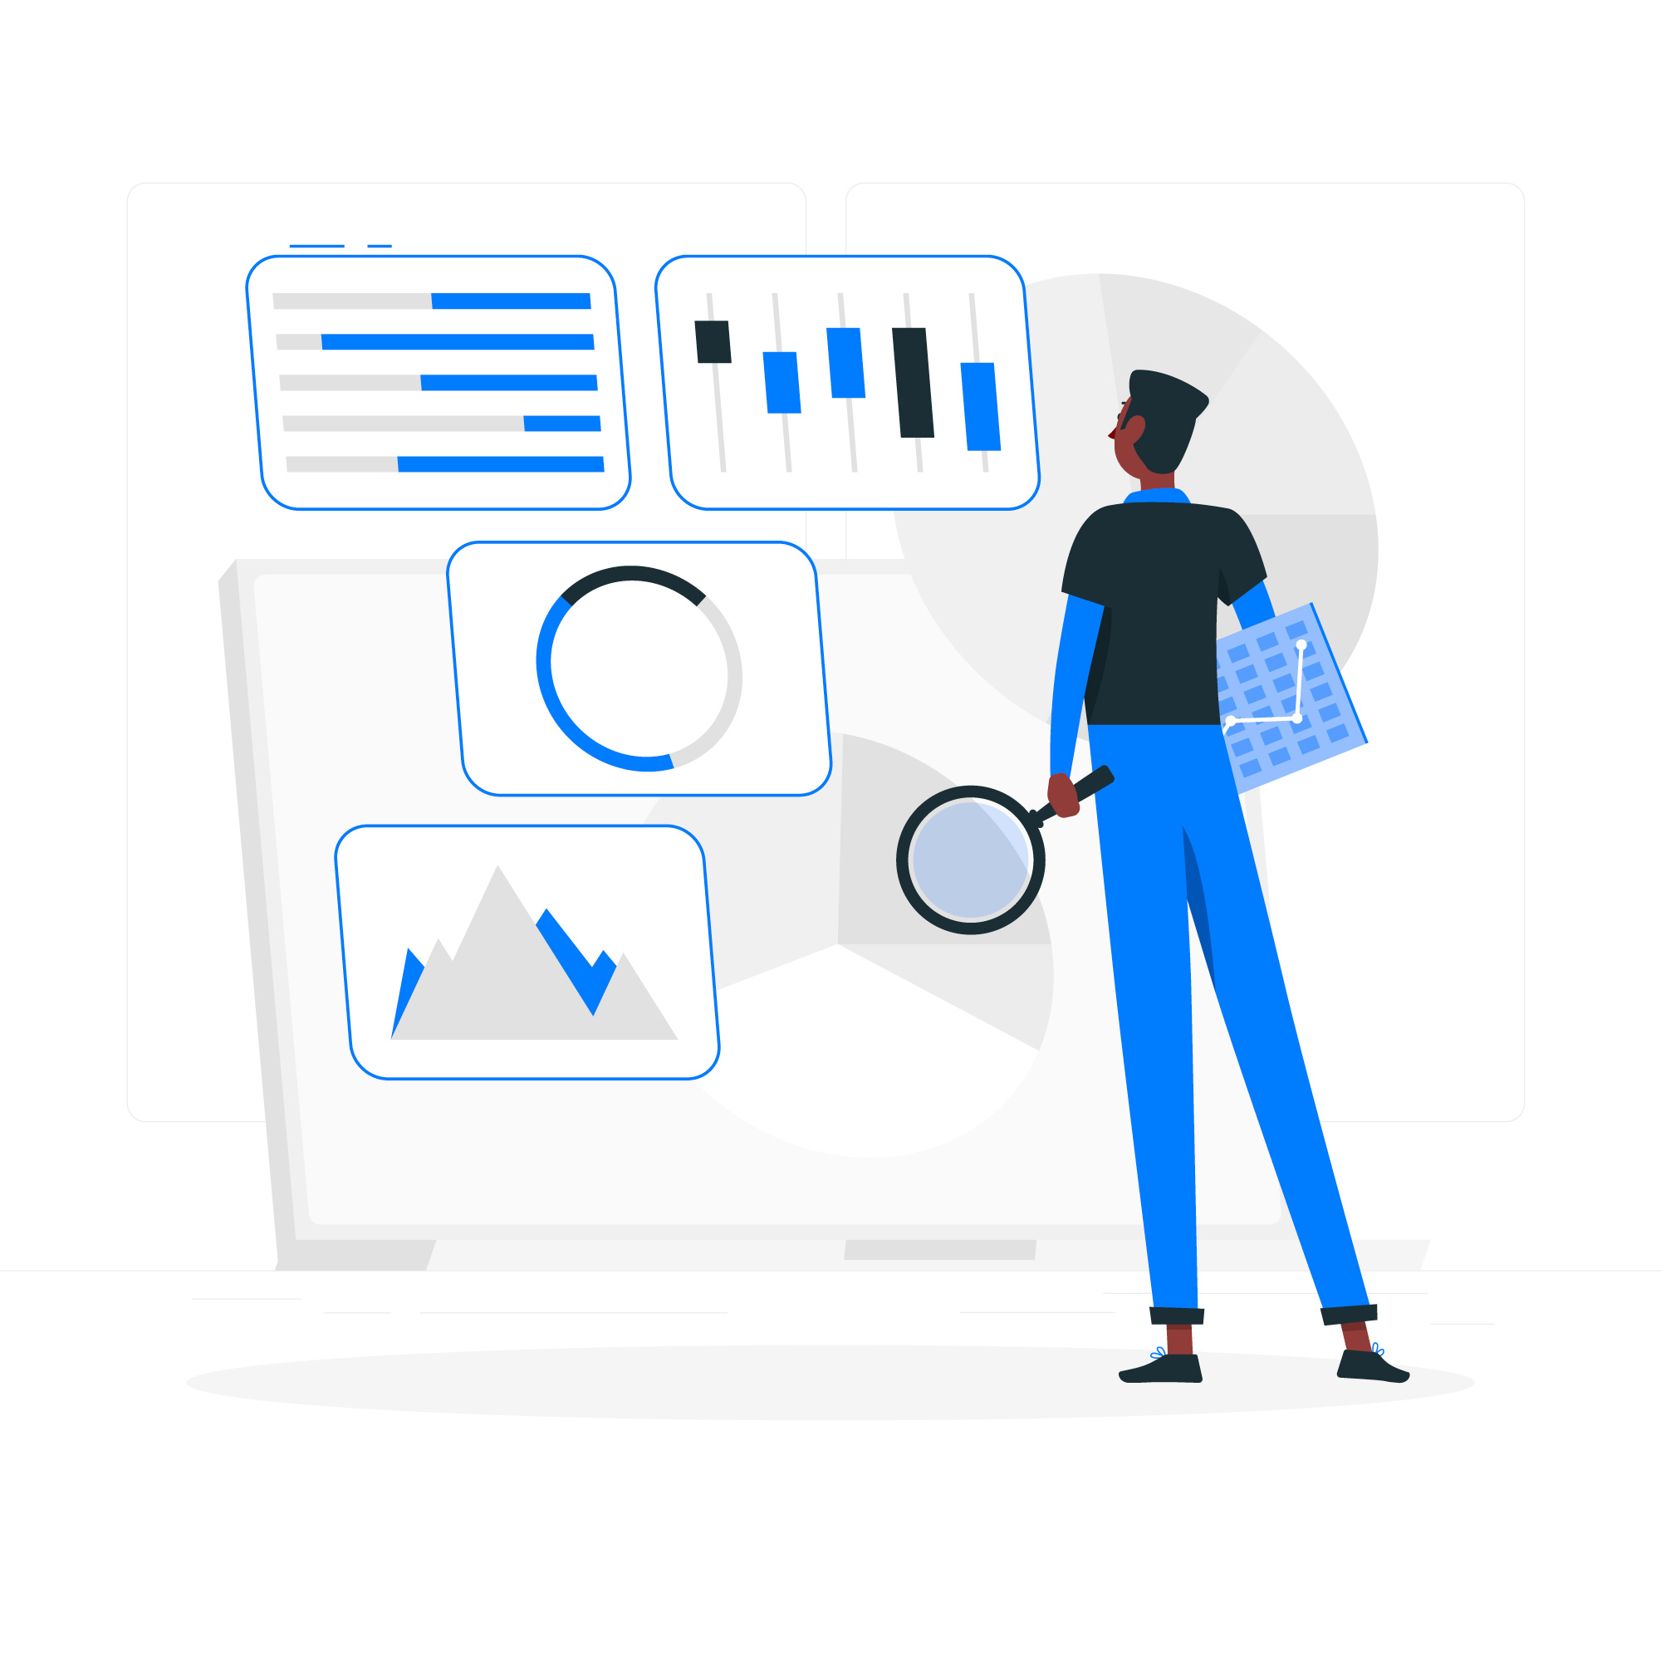

### **Trust Your Data. Every Time.**

*Data Quality: Fueling Trust, Powering Precision.*

In today's data-driven world, **decisions are only as good as the data behind them**. That's why the first pillar of **Data Katalyst** is dedicated to ensuring data quality—so you never have to second-guess the accuracy, completeness, or reliability of the insights you rely on.

With **Data Katalyst**, you're equipped with a full suite of tools to **detect, repair, enrich, and monitor** the health of your data—seamlessly and continuously.

### **DQ Assessment & Incident Management**

We start by helping you understand where data issues exist. Our system performs ongoing assessments, and anytime a quality issue is detected, an **incident is automatically created in Tracking System**, complete with failure details and record identifiers. This makes issue tracking simple, collaborative, and fully traceable across teams.

### **🛠 Resolution & Repair**

Data Katalyst doesn't just point out problems—it helps you fix them. Using a **rule-based cleansing framework**, we correct common issues like formatting errors, missing fields, and inconsistent values during data transformation. Each fix is backed by an **audit trail**, so you always know what changed and why.

### **✅ Validation Framework**

Our built-in validation engine ensures your data meets the highest standards of:

* **Validity** — Is the data correct?
* **Completeness** — Is any data missing?
* **Consistency** — Is it uniform across sources?
* **Accuracy** — Does it follow defined rules and relationships?
* **Timeliness** — Is it up to date?
* **Uniqueness** — Is each data entry distinct and non-duplicative?

All of this happens through **configurable business rules** that align with your specific data governance policies.

### **🔄 Data Unification**

Working with multiple systems? No problem. Data Katalyst enables **configuration-based merging of master data** across various sources. This ensures that your systems are referencing a **single unified value**, critical for confident reporting, optimised rule creation and stand of data and decision-making.

### **🧠 Smart Missing Data Handling**

Missing data? We've got it covered. **Data Katalyst** uses advanced AI-driven imputation techniques such as:

* **K-NN Imputation**
* **Hot Deck & Bootstrap Methods**
* **Single & Multiple Imputation**
* **Mode-based Filling**
* **Regression Imputation**
* **Deep Learning-Based Autoencoders**
* **Matrix Factorization (e.g., SVD, NMF)**
* **Random Forest Imputation (MissForest)**

These techniques intelligently populate missing values, enhancing dataset completeness without compromising data integrity or quality.

### **📊 Data Profiling & Gap Enrichment**

Get to know your data better with **exhaustive profiling dashboards**. Visualize patterns, distributions, and data quality metrics to quickly identify areas for improvement.

When it comes to missing or incorrect information, our **Gap Enrichment** feature steps in with:

* **Smart, rule-controlled enrichment**
* **Approval workflow engine** for every change
* **Full audit trail** of all modifications
* **Real-time notifications** to keep stakeholders informed

This ensures every update is transparent, traceable, and governed.

### **🔐 Authorization & Workflow Control**

Every manual data enrichment is governed by a **business-defined authorisation workflow**. No updates happen without proper oversight and approval, giving you full control while ensuring accountability.

### **🔔 Event-Based Notifications**

Stay informed with **configurable alerts and notifications**. Whether it's a new issue detected, a data enrichment pending approval, or a validation rule triggered, you're always in the loop.

### **🔎 Schema Inference & Audit Trace**

We automatically validate schema attributes such as data types, key constraints, value boundaries, and more. Every change made—whether automatic or manual—is recorded in a **comprehensive audit history**, ensuring traceability at every level.

### **What This Means for You**

With Data Katalyst's **Data Quality** pillar, you're not just managing data—you're **transforming it into a reliable asset**. You'll experience:

* **Fewer errors and surprises in reports**
* **Faster resolution of data issues**
* **Confidence in every dashboard and decision**
* **Peace of mind knowing your data is compliant and controlled**

Data quality is no longer an afterthought—it's the foundation. And with **Data Katalyst**, that foundation is rock solid.

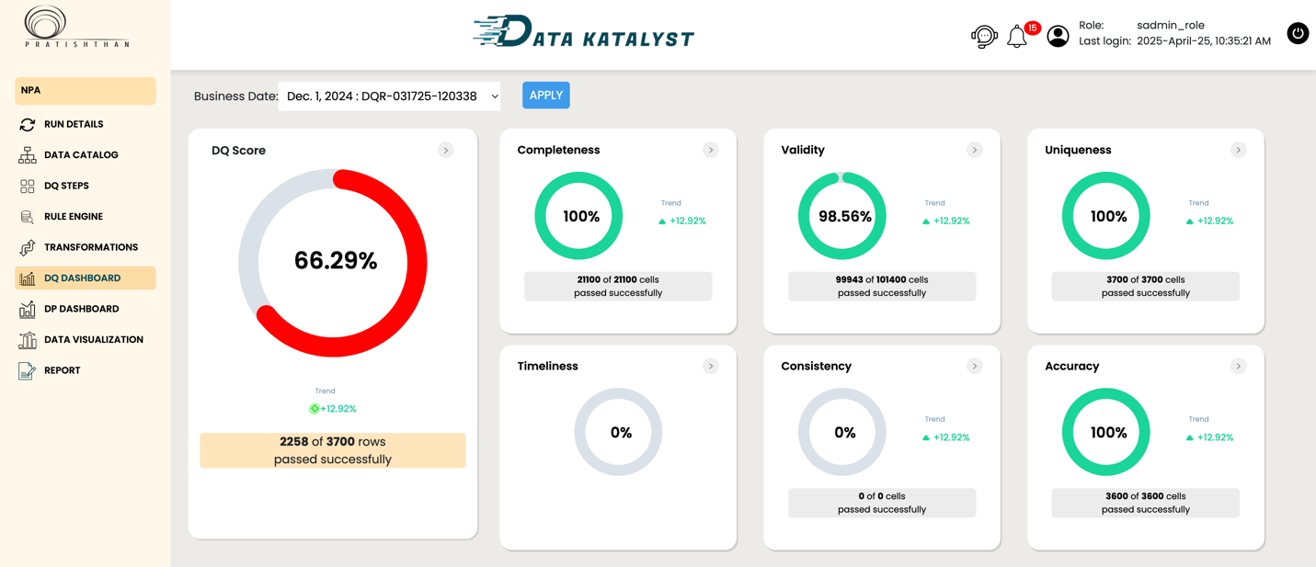

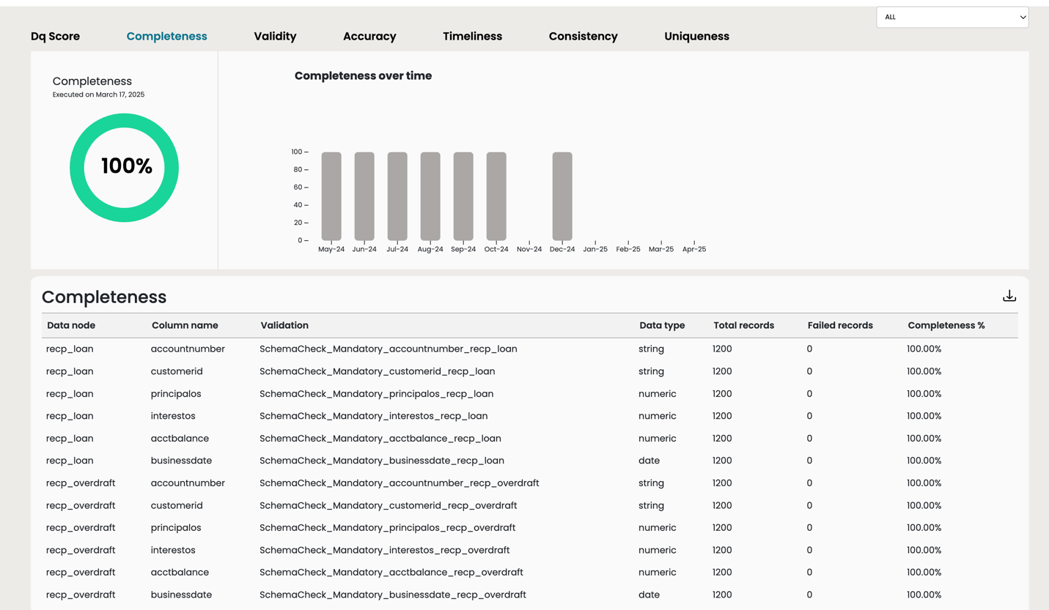

## 

## 

## 

## 

## 

## 

## 

## 

## 

## **Pillar 2: Data Governance**



### **Secure. Compliant. Accountable. Always.**

*Data Governance: The Rulebook of Trust, the Backbone of Insight.*

Data without governance is like a city without laws—chaotic and vulnerable. That's why **Data Governance** is the second core pillar of **Data Katalyst**, helping you **safeguard, govern, and take full control of your data assets**.

Whether you're handling sensitive customer information, complying with privacy regulations, or managing data access across teams, **Data Katalyst gives you the structure and security your organisation needs to thrive** in a regulated, high-stakes data environment.

### **🛡 Policy Enforcement & Governance Framework**

We help you **define and enforce data policies** across your organization through configurable frameworks. This ensures your data is used responsibly and consistently, from entry to transformation to consumption.

### **👥 Defined Roles & Responsibilities**

Governance is a team sport. With **Data Katalyst**, you can configure the roles of:

* **Data Stewards** — oversee data quality and usage
* **Data Custodians** — manage secure storage and transport
* **Data Owners** — define access and ensure accountability

Each role is mapped to clear responsibilities and permissions, so governance is not just theoretical, but operational.

### **🔒 Security & Access Control**

Security is embedded into the core of Data Katalyst. We utilise **industry-standard encryption techniques,** including:

* **AES** for data-at-rest
* **SHA** for hashing
* **RSA** for secure key exchange

Combined with **Role-Based Access Control (RBAC)** and **Multi-Factor Authentication (MFA)**, your sensitive data remains protected from unauthorised access—internally and externally.

### 

### **📜 Compliance with Privacy Regulations**

Data Katalyst is designed with **compliance in mind**. We help you align with global privacy laws like:

* **GDPR** (EU)
* **CCPA** (California)

This means proper handling of Personally Identifiable Information (PII), consent tracking, and access logging so you stay compliant and audit-ready at all times.

### **✅ Standards & Certifications**

We align with internationally recognised data protection standards, including:

* **ISO 27001**
* **PCI-DSS**

With Data Katalyst, you not only comply, it helps you **demonstrate** compliance confidently to regulators, customers, and stakeholders.

### **🔐 Data Ownership & Permissions**

We make data ownership clear. Through configurable **Permission Schemas** and **Access Controls**, you define who can see what, who can modify what, and who is accountable for what. This brings clarity and control to even the most complex data ecosystems.

### **🚨 Incident Response Planning**

In the event of a data breach or incident, **preparedness is key**. Our inbuilt incident response planning helps you track and manage:

* **Detection**
* **Containment**
* **Eradication**
* **Recovery**

Every incident is logged, traceable, and backed by action plans—so you can respond with confidence and speed.

### **⚠️ Risk Management**

No system is risk-free—but with Data Katalyst, **you're never caught off guard**. We provide mechanisms to identify, assess, and mitigate data risks proactively, minimising business impact and helping you build operational resilience.

### **📝 Audits & Data Entitlement Review**

Transparency is the backbone of trust. Our governance pillar includes **automated audit tools** to review:

* Who has access to what data
* When and how it was accessed
* Whether access aligns with governance policies

These insights help you refine access, tighten control, and pass audits with ease.

### **What This Means for You**

With the **Data Governance** capabilities of Data Katalyst, you get:

* **Clear ownership and accountability of your data**
* **Full alignment with security and compliance requirements**
* **Peace of mind knowing that every access, edit, or breach is tracked and managed**
* **A culture of responsibility and trust around your data ecosystem**

**Data Katalyst doesn't just protect your data—it protects your business.**

**Pillar 3: Data Management**



### **Structure, Store, and Scale—Effortlessly**

*Data Management: Turning Raw Data into Real Value.*

In today's complex data ecosystems, the challenge isn't just collecting data—it's managing it well. The third pillar of **Data Katalyst** is designed to give you total control over how data is extracted, transformed, stored, and used, ensuring your data infrastructure is fast, flexible, and future-proof.

### **🔍 Extraction Framework**

Pull data from virtually **any source or format**, whether structured or unstructured:

* Connects to **Databases, File Systems, HDFS, Cloud Storage**
* Works in **Batch and Streaming** modes for real-time or scheduled data flow
* Supports **Web Scraping** and **OCR** to ingest data from web pages or scanned documents

Whether it's sensor data or scanned invoices, we ensure no source is out of reach.

### **🗂️ Data Catalog**

Think of it as your **data GPS**—a centralized inventory of all your data assets:

* Enables easier search, classification, and usage of data
* Improves collaboration and metadata governance

You can't use what you can't find. Our catalog ensures every dataset is discoverable and documented.

### **🧊 Tiered Storage Architecture**

Optimize storage based on how often you need the data:

* **Hot Storage** — For real-time access (e.g., Redis, Aerospike)
* **Warm Storage** — For recent but less frequent access (e.g., RDBMS)
* **Cold Storage** — For archival and high-volume data (e.g., HDFS, S3)
* **Hydration engine** automatically moves data between tiers as needed

This architecture reduces storage costs without compromising accessibility.

### 

### **🔄 Data Lineage**

Track data across its lifecycle:

* Supports **forward and backward lineage** to trace how data flows and transforms
* Critical for **compliance**, **debugging**, and **audit readiness**

Know where your data came from, how it was modified, and who touched it.

### **🧬 Master Data Management (MDM)**

Centralized truth for all your core business entities:

* Manages **key dimensions like Customer, Product, Vendor, etc.**
* Eliminates duplication and mismatches
* Drives consistency across reporting and operations

With MDM, everyone—from analytics teams to executives—is working from the same playbook.

### **📊 Impact Analysis**

Visualize the downstream effect of changes to any field:

* Interactive dashboards show how updates affect **reports, models, and rules**

Avoid unintended consequences with full-field impact visibility.

### **🧪 Transformation Framework**

Easily apply complex data logic without manual coding:

* Built-in functions for **Cleansing, Aggregation, Joining, Filtering**, and more
* Custom logic supported via configuration

Spend less time scripting and more time delivering value.

### **🔐 Data Isolation**

Security and compliance by default:

* Each tenant's data is isolated with separate configurations
* Suitable for multi-organization environments or business units

Designed with security, privacy, and scalability in mind.

### **📤 Loading Framework**

Reliable loading into any destination:

* Supports **Databases, Files, HDFS, and Cloud Storage**
* Built-in **restartability** and **partitioning logic**
* Ensures **end-to-end traceability** with lineage metadata

Your data will land exactly where it should—safely and reliably.

### **🧱 Hierarchical Structures in MDM**

Model real-world relationships and organizational structures:

* Supports hierarchical levels within master data (e.g., product families, regions)
* Simplifies rule enforcement and drill-down reporting

A must-have for enterprise-grade governance and analytics.

### **✅ What This Means for You**

With **Data Katalyst's Data Management pillar**, you gain:

* End-to-end visibility of data flow and structure
* Streamlined access and governance through metadata and MDM
* Storage that adapts to your needs without exploding costs
* Infrastructure that's built to scale, secure by design, and easy to govern

**Data Management is the bedrock of your analytics journey—and with Data Katalyst, it's powerful, transparent, and future-ready.**

## 

## 

## 

## 

## 

## 

## 

## 

## 

## 

## 

## 

## 

## **Pillar 4: Data Analytics**



### **From Raw Data to Real-Time Business Intelligence**

*Data Analytics: Decode. Discover. Dominate.*

With **Data Katalyst**, analytics isn't an afterthought—it's the pinnacle. Our **Data Analytics pillar** transforms complex, fragmented datasets into intelligent, strategic insight. From operational dashboards to AI-powered forecasts, it's a one-stop solution that equips every stakeholder—analysts, business heads, product managers—with the tools they need to **understand the past, anticipate the future, and optimize the now**.

This is where **data becomes direction**.

### **🎯 Three Dimensions of Intelligence**

We cover all layers of analytical depth:

* **Descriptive Analytics** — What happened?  
   Slice and dice the data to discover trends, monitor KPIs, and catch anomalies.
* **Predictive Analytics** — What could happen next?  
   Leverage ML models to forecast demand, customer churn, risk, and more.
* **Prescriptive Analytics** — What should we do?  
   Simulate scenarios and test strategies—before you commit resources.

🔍 Whether you're diagnosing performance issues or simulating market shocks, Data Katalyst makes complex analysis intuitive and accessible.

### **⚙️ Advanced Optimization Techniques**

Why operate on gut feel when your data can show you the optimal path?

* Balance inventory vs. demand
* Right-size compute and storage costs
* Minimize overhead while maximizing service availability

Our optimization modules use historical patterns, business rules, and ML insights to fine-tune operations across functions.

### **📈 Trend Analysis & Metric Monitoring**

Pre-built templates help you instantly:

* Visualize KPIs by geography, product, channel, or time period
* Identify outliers, seasonality, or unexpected dips in performance

Actionable insights—without the analyst bottleneck.

### **🧾 Flexible Reporting Engine**

Not every report needs to be built from scratch. With Data Katalyst, you get:

* **Fixed Reports**: Predefined for recurring use
* **Ad-Hoc Reports**: Designed on-the-fly, by anyone
* **Excel Templates**: Pre-integrated with rules engine for smart summaries

Save time, reduce redundancy, and standardize business communication.

### **🧠 Machine Learning Made Plug-and-Play**

Don't just look at the past—**predict what's next.**

* Plug in your ML models using our configurable connectors
* Train models with unified, pre-processed datasets
* Automate scoring, feedback loops, and retraining

Use cases include fraud detection, credit risk scoring, demand forecasting, etc.

### **🧪 Scenario Simulation for Strategic Planning**

Create and compare hypothetical situations:

* What if sales drop by 15% in one region?
* What if a supplier goes offline?
* What if we reduce marketing spend by 20%?

Our simulation engine enables you to test business scenarios safely—without real-world risk. Perfect for CFOs, product managers, and supply chain teams.

### **📊 Beautiful Dashboards, Built Fast**

No code. No clutter. Just insight.

* Drag-and-drop dashboard builder
* Connect visualizations to live data sources
* Customize by business unit, stakeholder, or geography

Help teams *see* the story behind the data, instantly.

### **⚠️ Risk Assessment & Early Warning Signals**

Data Katalyst constantly scans your operations to:

* Detect performance deviations
* Emit signals for potential business risks
* Escalate issues via automated workflows

Get proactive, not reactive. Spot the iceberg *before* it hits.

### **💥 Stress Testing for Business Resilience**

Push your models to the edge:

* Simulate worst-case conditions
* Evaluate model robustness under extreme volatility
* Identify critical failure points

A must-have for regulatory readiness, disaster recovery, and risk management.

### **💡 Decision Support System (DSS)**

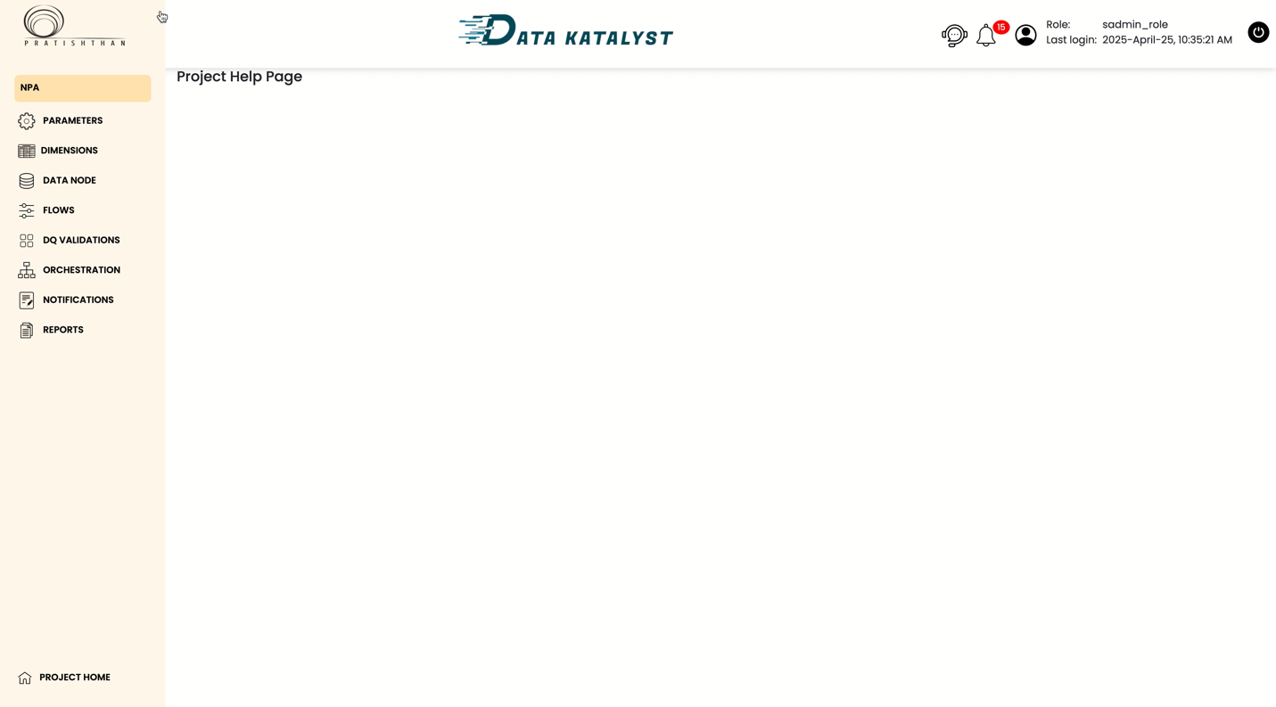Built to make you smarter, faster:

* Real-time data pipelines
* On-demand insights delivery
* Integration with your workflow tools (email, Slack, dashboards)

Every team becomes a **data-driven team** with Data Katalyst powering the decisions behind the scenes.

### **🔓 What You Unlock with Data Katalyst Analytics:**

✅ Better visibility across departments  
 ✅ Shorter decision-making cycles  
 ✅ Smarter forecasts and planning  
 ✅ Fewer blind spots, more agility  
 ✅ Competitive edge powered by AI & ML

### **Because your data isn't just numbers—it's your strategic superpower.**

With the **Data Analytics pillar**, **Data Katalyst** helps you put that power to work.

## **Chart Creation Video:**

## **Dashboard Creation Video:**

## 

## 

## **Pillar 5: DataOps**

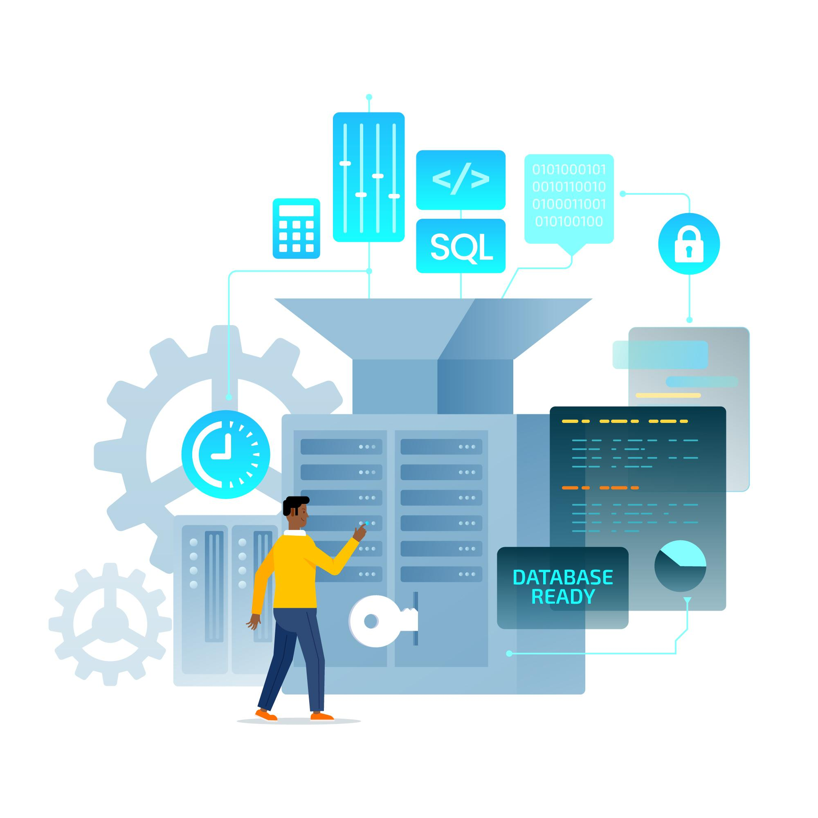

### **Where Data Engineering Meets DevOps for Velocity, Reliability & Scale**

*DataOps: Accelerating Data Delivery with Precision & Agility.*

In the modern data ecosystem, speed and stability are no longer trade-offs. **Data Katalyst's DataOps pillar** is the glue that connects data pipelines, governance policies, and analytics—all while ensuring **reliability, reproducibility, and rapid delivery**.

Built for modern enterprises, this pillar delivers **CI/CD for data**, **monitoring at scale**, and **collaboration across teams**—so your data flows never miss a beat.

⚡ DataOps is not just about automation—it's about creating a *culture of trust* in data, from ingestion to insight.

### **🔄 Continuous Integration & Deployment (CI/CD for Data)**

Push changes to your data models and pipelines **safely and continuously**.

* Version control for pipeline logic
* Auto-validation of transformations and schema changes
* Test automation for data quality rules

Go from dev to prod faster—with confidence.

### **🧩 Modular & Reusable Pipelines**

No more rebuilding the wheel. Create **templated data workflows** that can be reused across teams and projects.

* Drag-and-drop pipeline builders
* Parameterized components
* Environment-agnostic designs (dev → test → prod)

Reduce engineering overhead, increase delivery velocity.

### **🕵️‍♂️ End-to-End Observability**

Know what's happening at every step, in real-time.

* Monitor job execution and SLA breaches
* Automatic alerts for data anomalies, pipeline failures, or performance bottlenecks
* Visual pipeline lineage and health tracking

Never lose track of where data is, what it's doing, or when something breaks.

### **🧪 Test-Driven Data Development**

Bring engineering discipline to your data.

* Unit tests for data transformations
* Regression testing across versions
* Automated validation for incoming data streams

Ensure every change improves reliability—not risk.

### **🔁 Automated Orchestration & Scheduling**

Forget cron jobs and manual triggers. With Data Katalyst:

* Pipelines are orchestrated via rules, dependencies, and conditions
* Supports Airflow, Dagster, or native schedulers
* Includes pause/resume/retry functionality with alerting

Your data just works—on time, every time.

### **🧯 Incident Management & Self-Healing**

Mistakes and failures happen—what matters is how quickly you recover.

* Real-time error diagnostics
* Auto-remediation for known failure types
* Slack/email/MS Teams integration for alert resolution workflows

From chaos to control, within minutes.

### **👥 Collaboration Across Teams**

Empower data engineers, analysts, and business users to **work together seamlessly**.

* Role-based access to workflows
* Commenting, approvals, and version logs built in
* Dev—QA—Prod separation with smooth promotion

Bring DevOps best practices to data teams.

### **🔐 Security, Auditability & Compliance**

Designed for enterprise-grade control.

* Audit logs for every data operation
* Encryption at rest and in transit
* Integration with IAM systems for role-based control

Stay compliant and secure—no compromises.

### **🎯 DataOps is the Backbone of Modern Data Teams**

With **Data Katalyst's DataOps**, you can:

✅ Deploy faster, with fewer errors  
 ✅ Break silos between dev, ops, and data teams  
 ✅ Ensure reliability of mission-critical pipelines  
 ✅ Monitor, test, and heal your data processes in real time  
 ✅ Build trust across the organization

### **🚀 Transform Chaos into Control**

Whether you're managing 10 pipelines or 10,000, Data Katalyst helps you scale with precision.  
 Welcome to the era of **data done right, every time.**